Cloud Databases (Amazon RDS) Labs

Lab 1 - Exploring Amazon RDS
- AWS RDS Dashboard
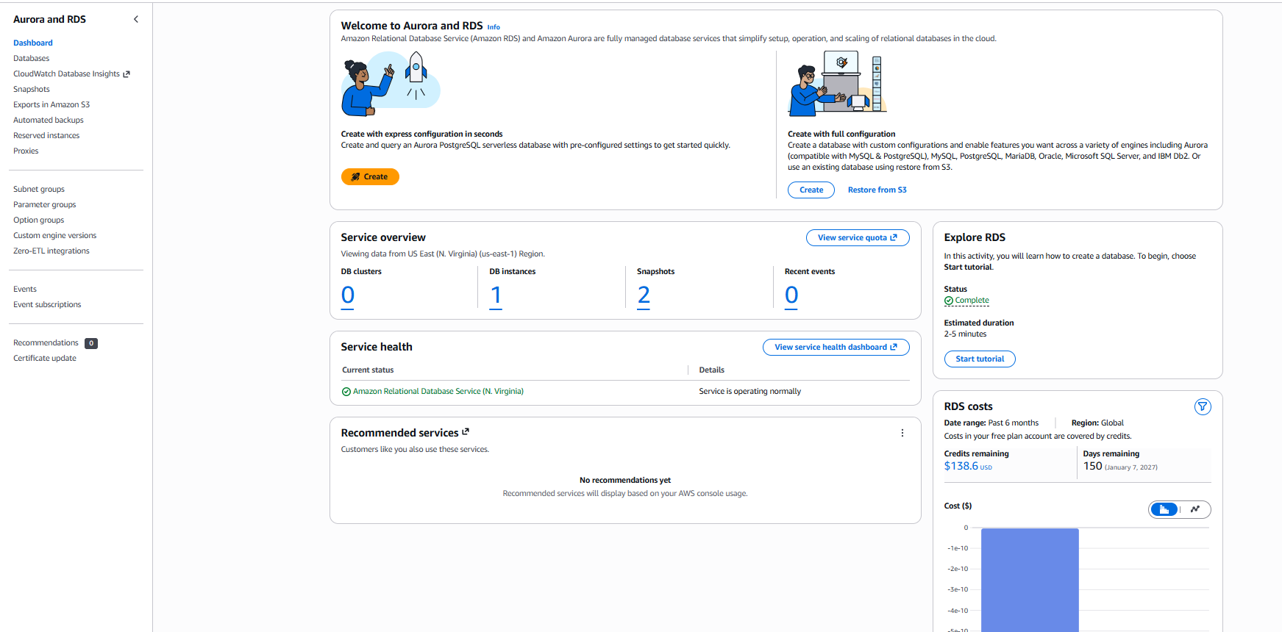
Lab 2
- Amazon RDS support

Lab 3 - Create Your First Amazon RDB Database
Method
- Standard Create (Full configurations – no standard creates)
Engine
- MySQL | Template: Free Tier
Database Identifier
- student-db
Master Username | Password
- admin | 1kFGvjx8o6pC
Database Name:
- academy
Public Access
- No

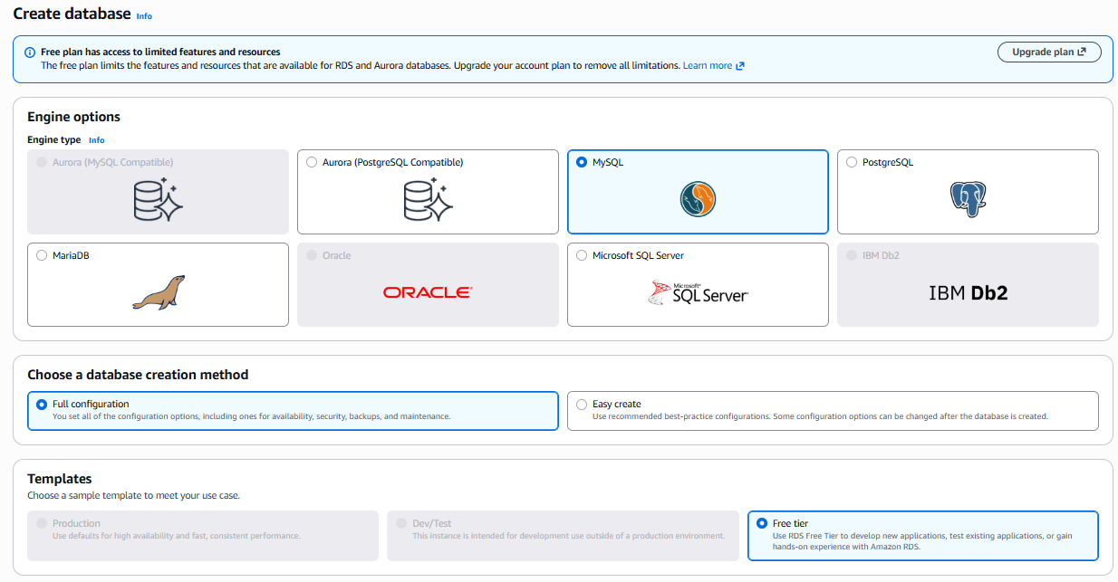
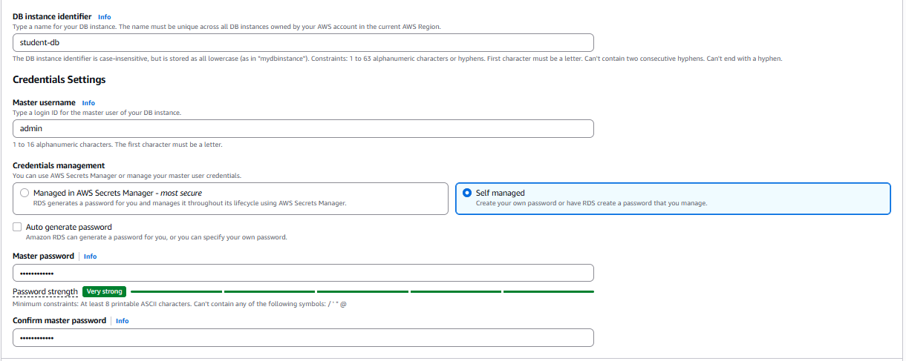
Public Access
- No

Database created

Lab 4 – Explore the Database Configuration
Audit database instance metadata, networking topology & storage settings
Engine
- MySQL Community
Availability Zone
- us-east-1a

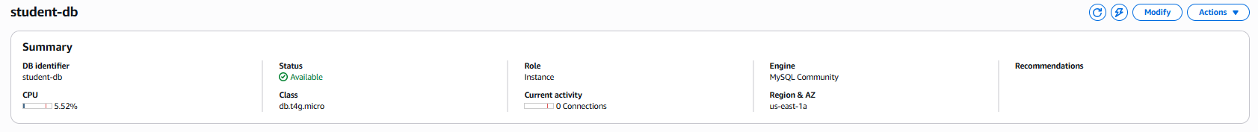
Storage
- 20 GiB
VPC
- vpc-0e9c534171f690a08
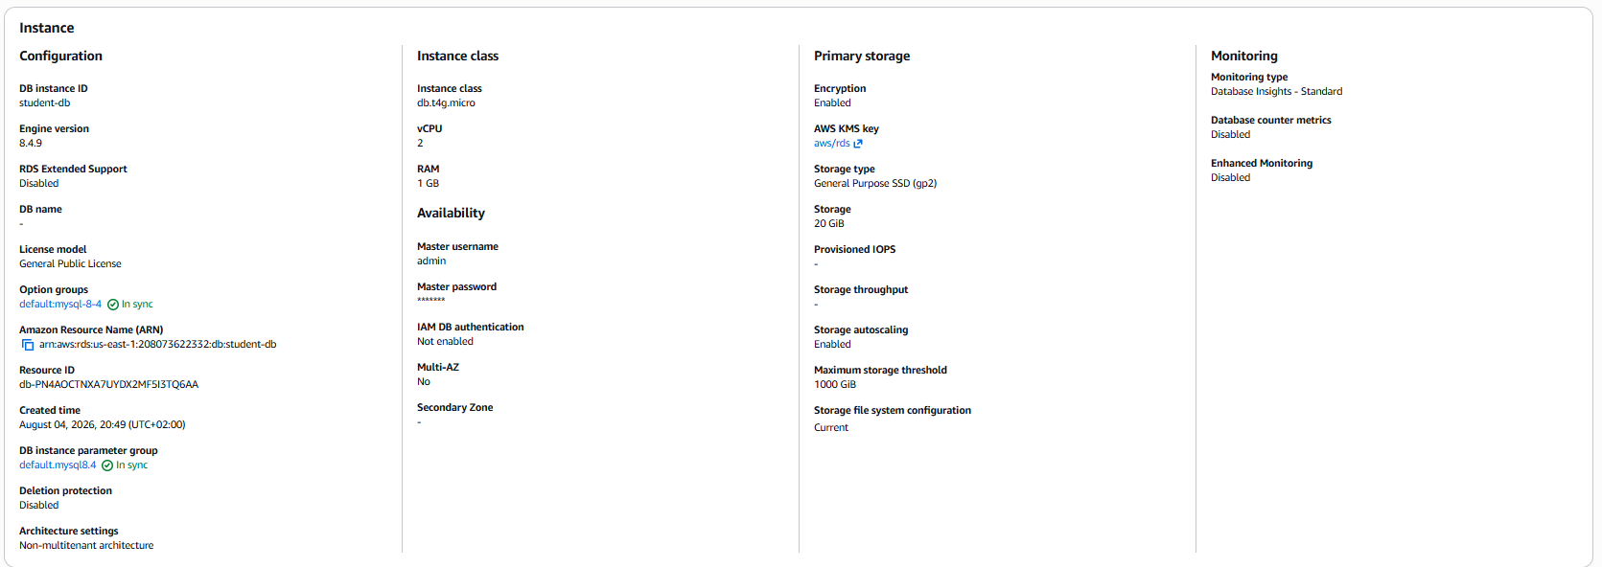
Endpoint
- student-db.cyf4o0qgmrxy.us-east-1.rds.amazonaws.com:3306
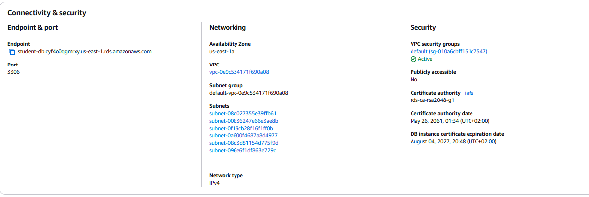

Lab 5 – Understanding Backups
Are backups enabled?
- Yes
How many days are backups retained?
- 1 Day

Why are backups important?
- They guarantee business continuity, regulatory compliance & recovery against accidental data corruption or malicious deletion.
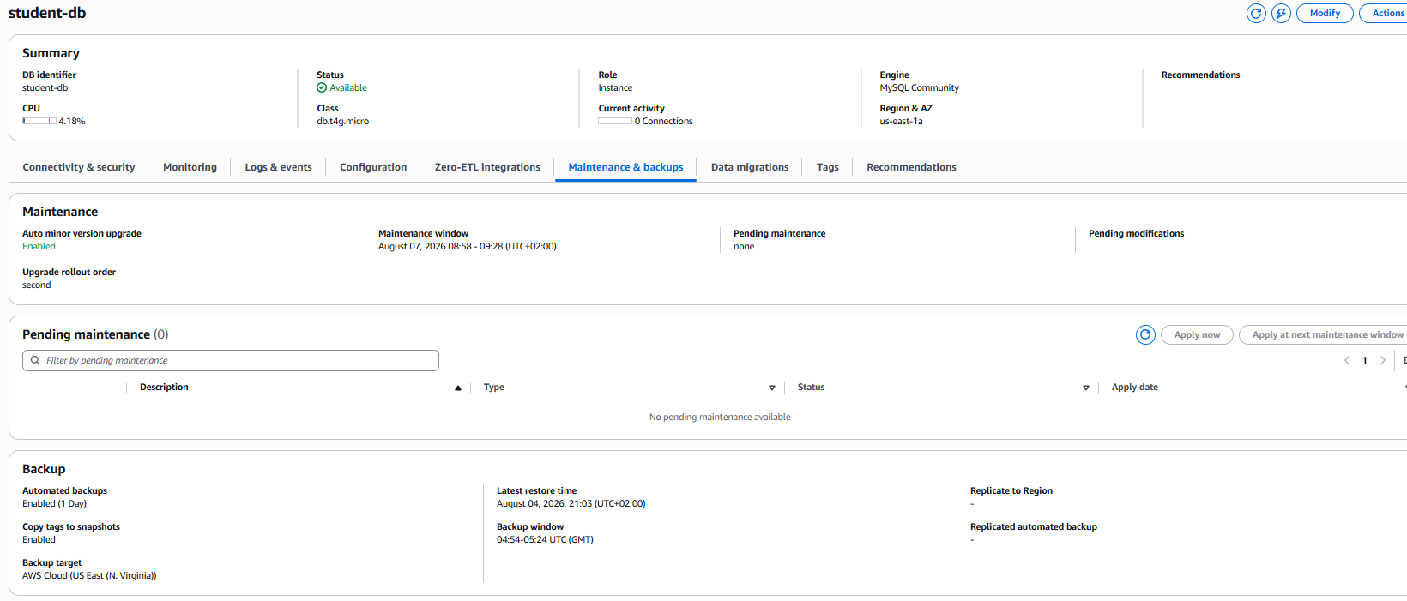
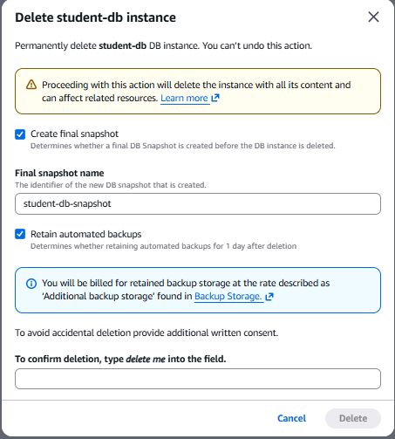

Lab 6 – Create a Manual Snapshot
Actions → Take Snapshot → Name: student-db-snapshot
Snapshot
- Student-db-snapshot
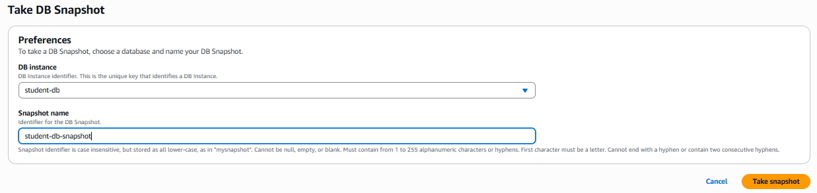
Snapshot created
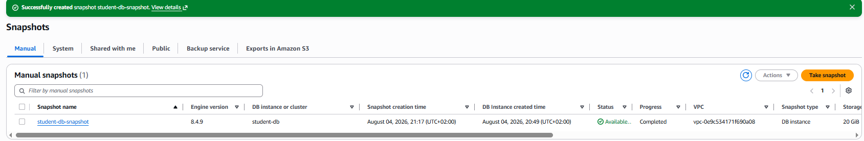

Snapshot details
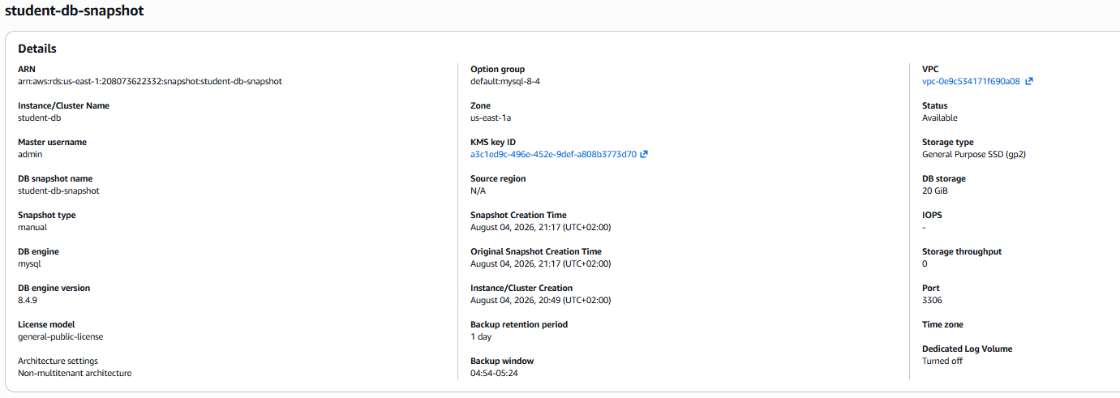

Lab 7 Restore from a Snapshot
Select Snapshot → Choose: Restore Snapshot
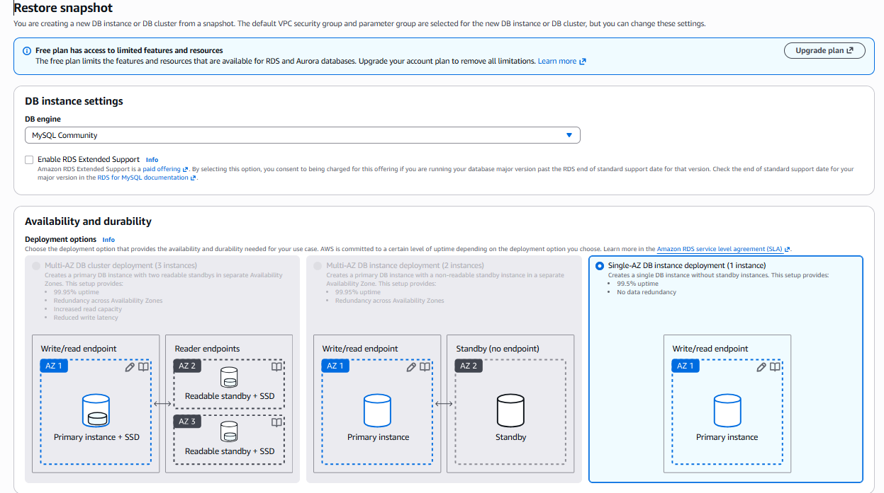

Restore Snapshot
- DB Identifier: student-db-snapshot-restore
Snapshot being restored
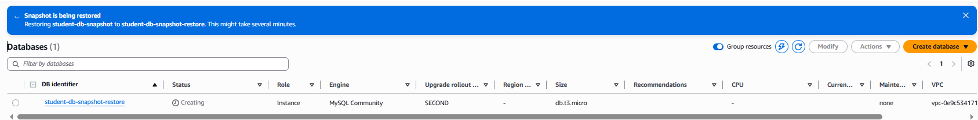
Snapshot restored
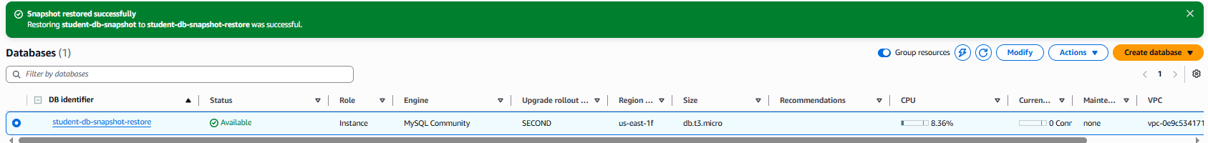

Lab 8 – Monitoring Amazon RDS
CPU Utilization
- 7.22%

Database Connection
- student-db-snapshot-restore.cyf4o0qgmrxy.us-east-1.rds.amazonaws.com:3306
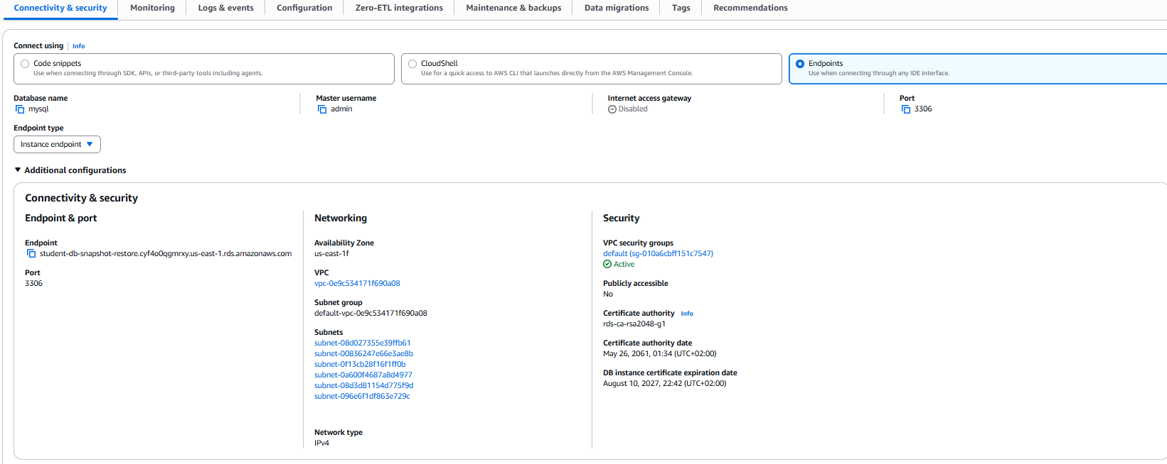
Free Storage Space
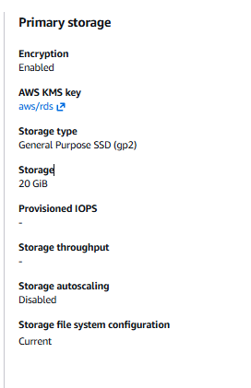

Read/Write Latency

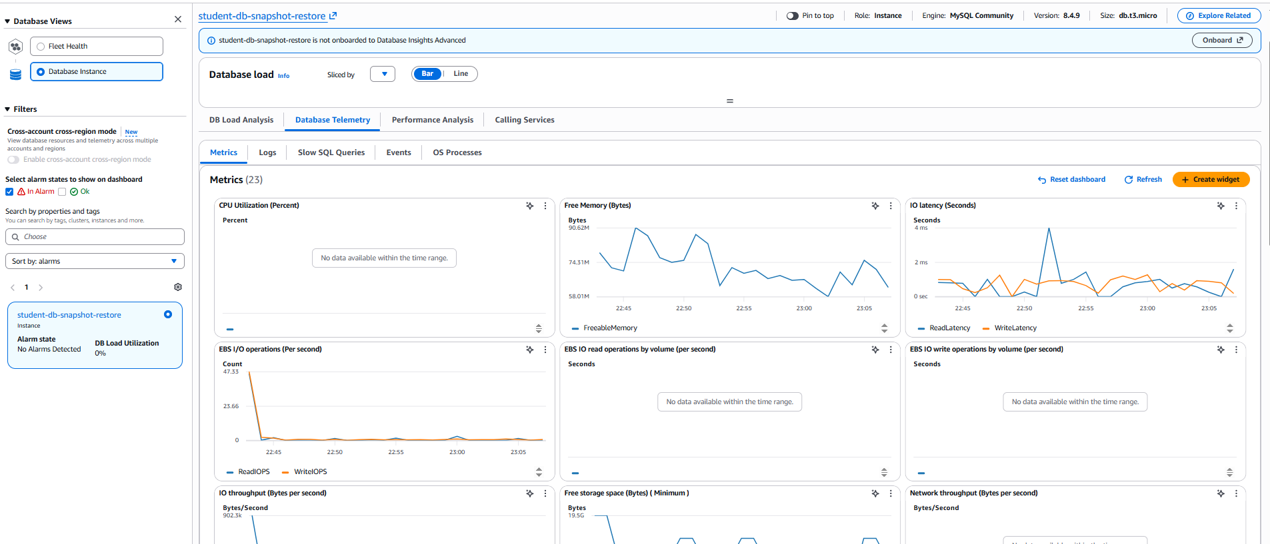

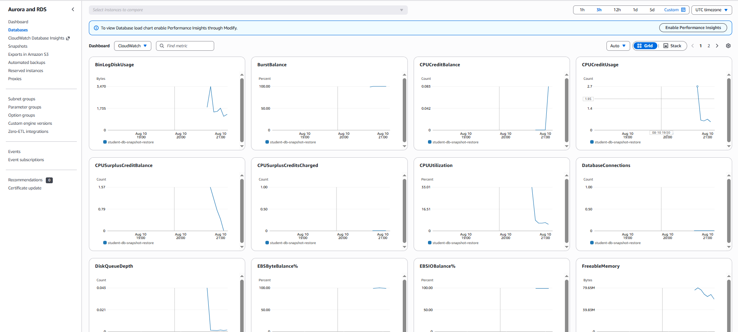

Lab 9 - Explore Amazon RDS Pricing

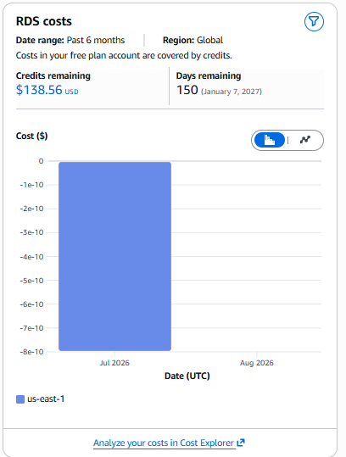

Lab 10

